ZOOM Guideline for the Fully Online Conference
NOTE:
◆ Before you enter the conference, please learn about the following guideline and make sure your PC’s microphone, camera is available.
◆ And please make sure your internet is available during the conference period.
◆ If you have any question or any assistance is needed, please feel free to contact our staff.

- ZOOM Download and Basic Guidelines
- Download the ZOOM on your PC (Please download it before testing time.) and complete the ZOOM install.
URL: https://zoom.us/
Author in China: https://zoom.com.cn/download
After download and open ZOOM, you can change the language displayed by Zoom on your ZOOM client if need.
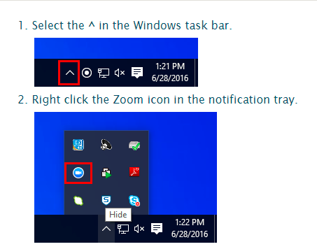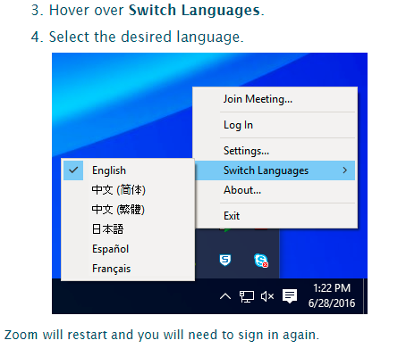

- Join in the conference by Room No. or Link. (Could be found in conference schedule)
Note: The Room No. or Link will be available only during the scheduled time.
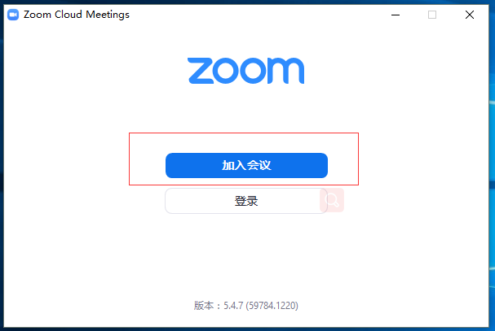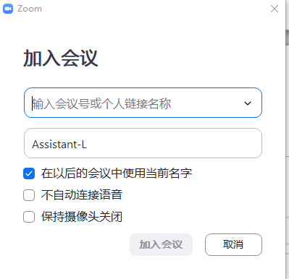
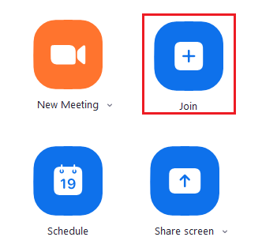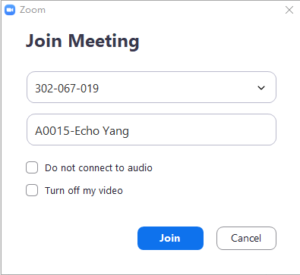

- Set up your Name.
- If you are conference committee member or keynote speaker, please set up your name by this format: your position-Full Name, such as, Keynote—Tracy Lee
- Or, if you are author, please set up your name by this format: Paper ID-Full Name, such as, T001—Gretchen Liu
- Or, if you are listener, please set up your name by this format: Listener-Full Name, such as, Listener—Gretchen Liu

Here are some tips:
- Share your screen to all participants when you make the presentation, by click the following button. Please prepare your presentation file in advance.
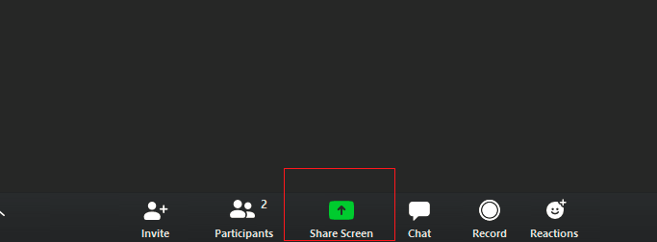
- See all participants by click it.
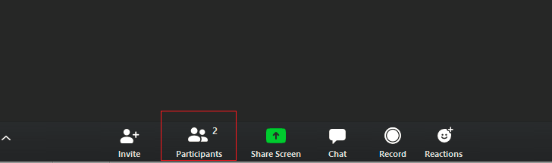
- There will be Q&A session during every keynote speeches and afternoon’s technical session. If you have any question, please just click raise hand or submit your questions by using the built-in chat window.

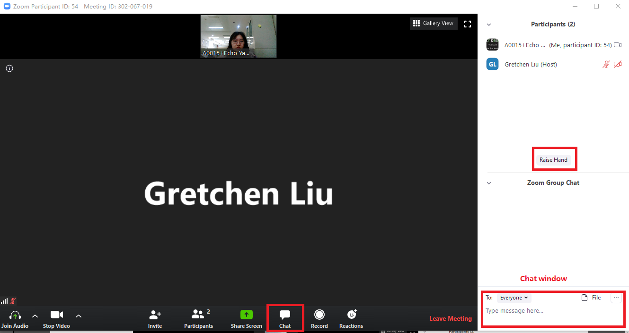
Or if it’s needed, you could also communicate with other participants using chat window.
NOTE: If you have any question or any assistance is needed, please feel free to contact our staff.

- ZOOM Test on time
- The conference organizer will arrange specific time as the ZOOM TEST for all participants. Please check your time in conference schedule. At that time, the staff will contact with you to check the microphone and presentation file screen share after you’re entering the conference. We suggest all participants to complete the test on time.

